Mission Prayer: South East Asia and India
May 22, 2023

Myanmar
As Cyclone Mocha approached Myanmar on May 14th, 2023, winds roared as fast as 175 miles
per hour, enough to make it a category 5 storm. Although the storm weakened slightly during
the final hours of its approach, Mocha still brought dangerous winds, downpours, and storm
surge when it made landfall just north of Sittwe, Myanmar. Almost 5.4 million people are
estimated to have been in the path of the cyclone, enduring winds in excess of 90 kmph across
Rakhine and the Northwest. Of these, nearly 3.2 million are considered to be most vulnerable
to the cyclone impact based on analysis of shelter quality, food insecurity and coping capacity.
This group is highly likely to have humanitarian needs in the wake of the cyclone.
There are local reports of possible deaths and of people being missing, including IDPs. The UN
and its partners are working to start rapid needs assessments as soon as access is granted to
better understand the impact of the disaster. Negotiations for access are ongoing.

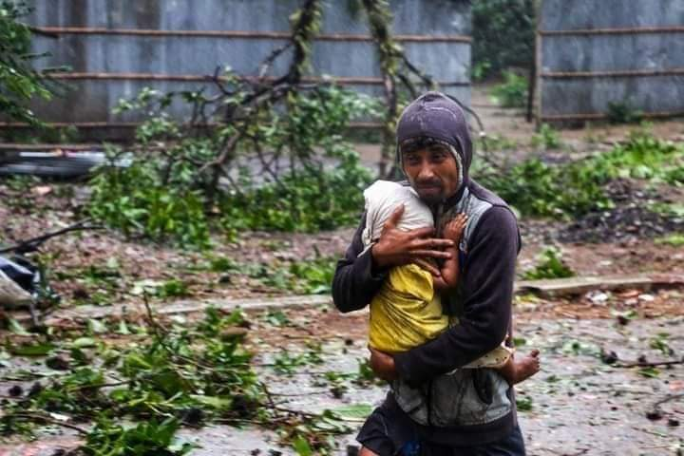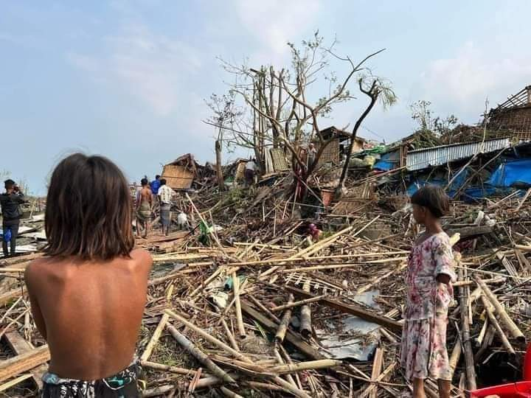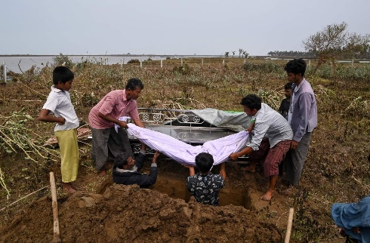
India
Large-scale violence broke out on May 3rd, 2023 between the tribal and non-tribal communities
after massive opposition by Manipur’s tribal communities to the demand of the Meiteis
community, for Scheduled Tribe (ST) status. The ‘Tribal Solidarity March’ was organized by the
All-Tribal Student Union Manipur (ATSUM) in the ten hill districts of the state on May 3rd, 2023
to protest against it, which led to clashes and violence between the two communities. Homes
and villages were being raided by mobs and families are fleeing to find shelter or make it to
relief camps.

Prayer Points:
Rose – Hill’s Academy in India
Update:
The situation in the hill for the tribal conflict is under control. They can move around only from 5 AM to 11 AM. After that it is under curfew. There is scarcity of water. Electricity is working. They will not have school but will adjust the extra holidays with summer vacation.

Prayer points:
1. Technical issue with the money transfer which is resolved
2. People who have come forward to take water baptism
3. Men’s fellowship and weekly prayer that is growing stable
4. Youth who are responding to the gospel

Pastor Joshua – Living Hope in India
Thank God for:
- Family of God Church has been registered as a different entity on March 20th
- Five house fellowships that are doing well. The new house fellowship we are going to start
from this week.
- Men’s fellowship and prayer, Bible study and church prayer that are a great encouragement.
- The new batch of women who have joined the women project
- The adolescent girls project that is making an impact in the lives of adolescent girls
- Availability of doctors (3 specialist doctors, one dentist and one general physician) for the
clinic and the good response from the community

Please pray for:
- A special youth meeting planned for 15 May 2023
- A church team will travel to Karur (2000kms away) to conduct VBS for migrant Bengali children
- The VBS 2023 in Taldi that is planned for the month of June
- FCRA Renewal for Living Hope to be granted soon
- Training center’s work to be completed soon.
- Father of Priya Sarkar (school teacher) who has suffered a stroke and is limited in his
movements.
- Situation in the state of Manipur. There is curfew imposed and many villages are cut off as
there is a communal tension between tribals, who are mostly Christians, and the people
who are living in the valley.
- Sarala Naskar who has undergone a second knee replacement surgery to recover soon
- Need for new CCTV cameras in the new school building and the fire hydrant installation
- A deacon who is undergoing deep depression which affects her family and her relationship with her husband
- People who are waiting for marriage to get suitable match soon- Paritosh, Priya and Sangita
- Need for a leader for the youth as we have about 200 beneficiary youth
- Need for more Sunday School teachers
- Financial need of INR 1,10,000 for a E-rickshaw as livelihood for Shambu from Madhyamgram fellowship.

Pastor Joseph – Beulah Home in Myanmar
Prayer points:
- praying for many of homeless and refugees.
- Praying for people dying from the civil war and famine by economic and political crisis.
- Beulah children's home.
- resettle and relief program for Myanmar's homeless and famine.
- Peace for Myanmar's people.

Judson – Peace & Joyce Travel Agency in Myanmar
Updates:
Serving needy Myanmar migrant children by running computer, English, guitar classes since April till
mid-May, before school season.
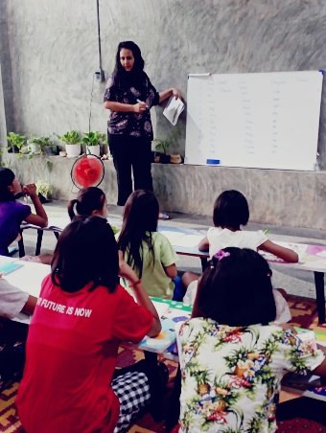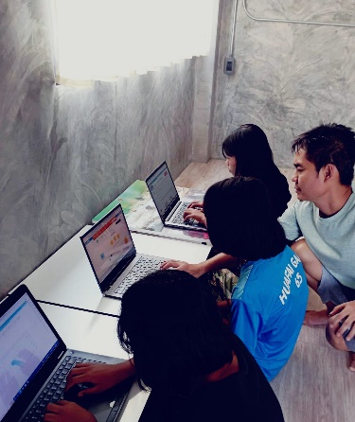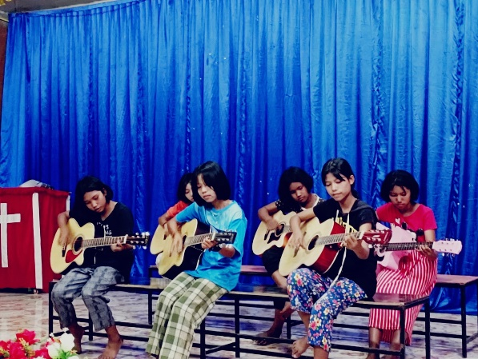

Recent updates of Serving IDPs, Kayah state, where they regularly deliver medication supports to their ground medical mission workers, medical care for IDPs in Kayah state.

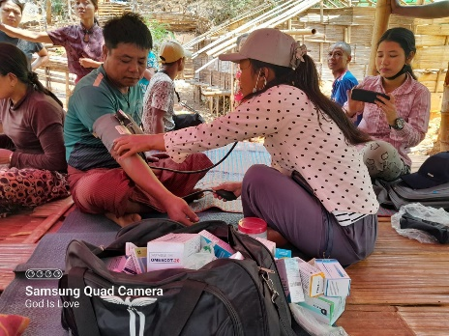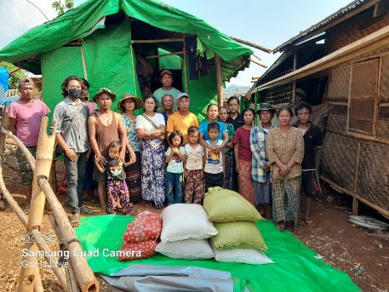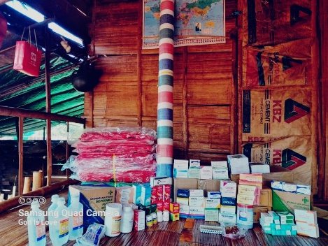
And, also busy helping few new IDP children fled from Myanmar side, staying in mountain village, due to threats & arrests, thousands of children sheltering in this mountain village in Thai side, and there's school in village. Many more children coming in & some needing help with shelter, school fees, uniforms. Really need prayers for His direction, for our next steps in ministry here & start another step. Seeing many needs on ground & our hearts burden to serve, but we really don’t know what to do next. Many IDP children fled to Thai border side, from areas where junta continuously bombed & attacked. They arrest, kidnap, kill, parents and in some areas they even arrest children. And, due to junta's threats & cut off supports to IDP areas in Myanmar, it is harder to connect with ground channels in some areas except continuing supports to IDPs in Kayah state. we request our ground channels to take gospel with them, where ppl need most. we have asked some update situation from our ground channels & they will send soon.

Prayer points:
- PTL that Sandra has final gotten her Thailand ID.
- Pray for God to give wisdom to Sandra and Judson facing many more children fleeing from
Myanmar. They need shelter, school fees support and uniforms etc.
- Pray for the IDP facing of many violent (unlawful arrest, force kidnaping, and killing etc.)

Pawtie C Mo – Blessing Home Orphanage
Update:
On April 20th, Pawtie C mo’s daughter; Grace has gone back to our heavily Father and resting well in is arm.

Prayer points:
- Pray for Pawtie c mo’s mourning for her loss of daughter.
- Pray for the strength on taking care of the orphanage and the church.
- Pray for Pawtie c mo’s spiritual life as she is weak due loss of her daughter and husband
recently.

宣教祈禱運動: 印度/東南亞
五月二十二日

緬甸
2023 年 5 月 14 日，摩卡颶風逼近緬甸，風速高達每小時 175 英里（280 公里），足以使
其成為 5 級風暴。 儘管風暴在接近的最後幾個小時略有減弱，但摩卡在緬甸實兌以北登
陸時仍然帶來危險的大風、傾盆大雨和風暴潮。 據估計，將近 540 萬人處於颶風路徑上
，在若開邦和西北部遭受超過每小時90 公里的風速。 根據對住屋質量、糧食不安全和應
對能力的分析，其中近 320 萬人被認為最容易受到颶風影響。 該群體在颶風過後極有可
能有人道主義需求。
當地有報告指出可能死亡和失踪人囗（包括國內流離失所者）的情況。 聯合國及其合作
夥伴正努力爭取在獲准進入緬甸後立即開始有關需求的評估，以便更好地了解災難的影響
。 有關訪問談判正在進行中。
印度
2023 年 5 月 3 日，在曼尼普爾邦的部落社區大規模反對 Meiteis 社區對在冊部落 (ST) 地位
的要求後，部落和非部落社區之間爆發了大規模暴力事件。 2023 年 5 月 3 日，曼尼普爾
邦全體部落學生會 (ATSUM) 在該州的十個山區組織了“部落團結遊行”以抗議，這導致
了兩個社區之間的衝突和暴力。 暴民襲擊了房屋和村莊，許多家庭正在逃離尋找避難所
或前往救援營地。

代禱事項：
Rose – 印度山區學校
最新情況：
山上部落衝突的局勢得到控制。 他們只能在早上 5 點到 11 點之間自由出入。之後便是宵
禁時段。 他們缺水，電力供應正常。學校停止運作，但會將額外的假期與暑假調整。
代禱事項：
1. 已解決的匯款技術問題。
2. 願意前來洗禮的人
3. 弟兄團契和每週的禱告會穩定成長
4. 對福音有回應的青少年

Pastor Joshua – 印度活望事工
感謝神：
1. 神家教會於3 月20 日註冊為獨立的機構
2. 五個家庭團契都很好的成長。 我們將從本週開始另一個新的家庭團契。
3. 弟兄團契和禱告會，查經班和教會禱告會是極大的鼓勵。
4. 新一批加入女性項目的女性
5. 青春期少女項目正在影響她們的生活
6. 診所醫生（3 名專科醫生、1 名牙醫和1 名全科醫生）的服侍以及社區的良好反應
代禱事項：
1. 計劃於 2023 年 5 月 15 日舉行的特別青年會議
2. 教會團隊將前往 Karur（2000 公里外）為孟加拉移民兒童進行暑期聖經班
3. 計劃於 6 月份在 Taldi 舉行的 2023 暑期聖經班
4. 祈求活望事工於 FCRA 的 更新申請盡快獲批
5. 培訓中心工作可以盡早完成。
6. Priya Sarkar（學校老師）的父親中風，行動受限。
7. 曼尼普爾邦的情況。 實行宵禁，許多村莊與外界隔絕，因為部落（主要是基督徒）
與居住在山谷中的人們之間存在社區緊張關係。
8. 接受第二次膝關節置換手術的Sarala Naskar 可以早日康復
9. 需要在新校舍安裝新的閉路電視攝像機和安裝消防栓
10. 一位患有嚴重抑鬱症的執事，這影響了她的家庭和她與丈夫的關係
11. 等待婚姻對向的人- Paritosh, Priya 和 Sangita
12. 由於我們有大約 200 名青年，因此需要一名青年領袖
13. 需要更多的主日學教師
14. Madhyamgram 獎學金需要 1,10,000 印度盧比購買一輛電動人力車作為 Shambu 的生計。

Pastor Joseph – 緬甸Beulah 兒童之家
代禱事項：
- 為許多無家可歸者和難民祈禱。
- 為死於內戰和因經濟和政治危機而飢荒的人們祈禱。
- Beulah 兒童之家。
- 緬甸無家可歸者和飢民的安置和救濟方案。
- 緬甸人民的和平。

Judson & Sandar – 緬甸P& J Travel
最新情況：
從 4 月到 5 月中旬開學前，通過開設電腦、英語、吉他課程為貧困的緬甸逃難中的兒童提
供服務。
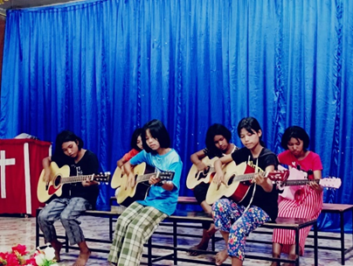
克耶邦服務國內流離失所者的最新消息，他們定期向地面醫療人員提供藥物支持，為克耶邦的國內流離失所者提供醫療服務。
而且，還忙於幫助一些新的從緬甸逃離的國內流離失所兒童，由於威脅和逮捕而留在山村，成千上萬的兒童在泰國這邊的山村避難，村里有學校。 更多的孩子來了，有些孩子需要住所、學費和校服方面的幫助。 真的需要神的帶領，請為我們在這裡事工的下一步和開始另一個步驟祈禱。 看到當地的許多需求和我們內心很有負擔，但我們真的不知道該怎麼做。 許多國內流離失所兒童從軍政府不斷轟炸和襲擊的地區逃往泰國邊境。 他們逮捕、綁架、殺害父母，在某些地區他們甚至逮捕兒童。而且，由於軍政府的威脅和切斷對緬甸境內流離失所者地區的支持，在某些地區與地面渠道聯繫起來要困難一些，除了繼續支持克耶邦的國內流離失所者。我們要求我們的本地聯絡人將福音傳給他們，這是人們最需要的！我們已經從我們的本地聯絡人詢問了一些最新情況，他們會很快讓我們知道。

代禱事項：
- 感謝主！Sandra 在泰國申請身份證已經成功取到了。
- 求神賜智慧給Sandra 和Judson 面對更多逃離緬甸的孩子。 他們需要住所、學費支持和校服等。
- 為國內流離失所者面臨許多暴力（非法拘捕、強行綁架、殺戮等）代禱

Pawtie 師母 – 福氣孤兒院
最新情況：
4 月20 日，Pawtie 師母的女兒 - Grace 已經回到我們天父身邊，安息在祂的膀臂中。
代禱事項：
- 為 Pawtie 師母失去女兒的悲痛禱告。
- 為照顧孤兒院和教會禱告。
- 為Pawtie 師母軟弱的屬靈生命禱告，因為她最近失去了女兒和丈夫。

